Casa Vietii

House of Life
Summer 2007

We’re Alive!!!!

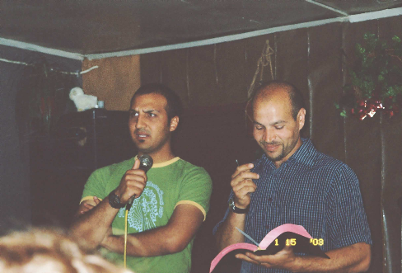After waiting several years to finish his DTS, it’s finally over. We had a really good, refreshing time. We spent 2 weeks in Turkey and then 6 weeks in Bulgaria. You know, even as missionaries you can get into a comfort zone and we had. We needed this time to get back on track and to put our priorities in order. Although we minister to the gypsy communities in and around Sighisoara, it was such a reminder to always depend on God to work through us while we ministered to the gypsy community in Bulgaria. It also brings a greater dynamic for Sorin and I as we minister together.
Sorin preaching in Kotel, Bulgaria
Jadyn took everything in stride and did great. Even when she cut her first two teeth while we were preparing to leave Turkey she didn’t whine.

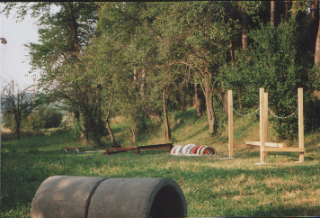After we returned from outreach, we then went to England for a month to bring our supporters up to date with what’s happening here and to show off our daughter to our family…..especially Kayleigh, Jadyns sister who she’d never met. Thanks to all the family and friends that helped with accommodations and the churches where we were allowed to share our ministry. We finally arrived back in Sighi on the 10th of July ‘chomping at the bit’ we couldn’t wait to get back into the swing of things…..which we have.

Our first week back was blessed with the arrival of Sherry and Mark Havira from Alabama. We spent the week building the first few modules of a playground for the kids in Soard. Sherry and Mark, our friend Heather (who did the outreach with us and was visiting us for a few days), several people from Soard and ourselves braved the temperatures even in the afternoon. It was 40ºC (that is 104ºF) in the shade . . .and after noontime there wasn’t any shade where we were working. (I had to leave with Jadyn). By this week Romania was ‘code red’ which means that nobody is allowed to work between the hours of 11am and 5pm because of the heat. As of July 24th, 30 people have died from heat-related problems in Romania. We have also had many areas with a draught problem. If you remember, most of the people survive from their well water and many have dried up. The ground is cracking and the crops are failing. Many of the gypsies in the villages depend on their cabbage, corn and potatoes for feeding their families through the winter and selling a few crops for survival. Please pray for rain and the families that have been so affected.

We decided to build the playground instead of taking the ladies away on a retreat this year. Funding, time and personel was limited and it was either one or the other. We worried that the ladies might be disappointed about the playground. But, in God’s special way of allowing us to know we had followed His direction, He had one of the ladies at the ladies program in Soard, Ana, bless us by saying how happy they were that we were doing something that’s going to last for their children. As with most mothers everywhere, they didn’t mind at all sacrificing their retreat.

Whilst we were in Bulgaria, it became apparent just how important education is for the gypsies and just how easy they give up. Many gypsies feel that finishing school as quickly as possible and helping in the home or in the fields is more important than ‘wasting their time’ on education because they feel they’ll never make anyone important anyway.

A lot of the kids in Soard don’t go to school during the winter because the temperatures are so cold and they have to walk 3 miles to school. So we started to pray about using the mini bus to take the kids to school. Our mini bus only has 8 seats and there are at least 25 kids which need transporting. Although it will mean a few journeys, we want to encourage the kids…and parents by giving this service. God has also showed us that an older bus may be a possibility. We have told several people in other areas and we are praying that God would provide resource. Please pray with us that before the winter comes we can come up with a better solution, i.e. a bigger bus. The laws have now changed in Romania and we can bring an older vehicle in to register and we can also use a right hand drive bus.

This week we decided to take all the ladies from the villages out for the day to Vila Franka, a park which sits on the hill overlooking Sighi. Tuesday we brought the ladies from Soard, Wednesday from Secuieni and Thursday from Sighisoara.

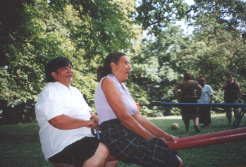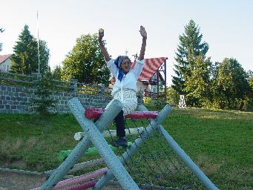Vila Franka is located at the edge of the forest so it was much cooler and there was plenty of shade. We had a great time…especially laughing at Estera who’s 73 yrs old and played on the swings, seesaw and even played football with us. Some of you may remember Estera from two years ago riding high on the play equipment! What a blessing to see them enjoy a day of fun and relaxing with their friends.

Estera in 2005!

Estera in 2007!

Unfortunately, but understandably because we’ve been away so long, our two construction workers have found alternative employment. Fane had been with us 5yrs but needed to provide for his young family. He is now working in Spain. Vasile who’d been with us 3yrs found work with building our new church and although he wants to come back and work for us, his salary there is more than we can pay him and unlike with us his wages are guaranteed every month. He also suffers terribly with his back, the church understands this and he has more of a managerial job where he can delegate the harder jobs.

At Casa Vietii our next job is laying concrete inside the new building and Vasile would find this too hard in his condition. So please pray for new workers, Sorin is finding it very difficult working by himself. The Medical Clinic and Women’s Shelter will still be progressing slowly, but pray with us that the workers and finances will come soon to accomplish some work before winter so we can complete work inside the building during the colder months.

Mia did a great job running the ministry, going to school, and being a mother while we were gone so many months. And with all she had to do, she did really well with her exams with very high marks bless her. We are really proud of her. It’s not easy to run a ministry on your own and although I know she feels incapable, she is capable and we’re so grateful to her and for Lydia’s help in the village with the ladies program.

We are now preparing all the brochures and literature ready for the centre opening full time again. We’ve been closed so long. We can not wait to be open to the public again. If any women came to the centre wanting help we still helped them, but we didn’t advertise being open because of all the construction work inside Casa Vietii which has been carried out. I will send pictures next time, my camera no longer works, but we will borrow one.

So, again, there is plenty of things to be grateful for, many answers to prayer and many other things to pray for. Thank you so much for all your support and please don’t hesitate to contact me with any questions or comments.

Many blessings
Jill xx

Please stay in touch. Let us know how we can pray for you. Contact us if you need any more information or if you have any suggestions. For donations to any of the projects or the operation of Casa Vietii, please contact me at jillascough@hotmail.com.

If you are in the United States,
please contact Barbara Glenn at tbglenn@bellsouth.net
or
Choose Life, Inc.
2006 Franklin Street, Suite 204
Huntsville, AL 35801
256.534.1996
www.chooselifehuntsville.org
for tax deductible donations.

