Casa Vietii

House of Life
January 2007

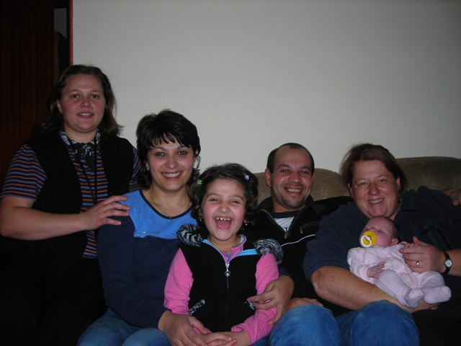
HAPPY NEW YEAR from the Casa Vietii Team! ( pictured from left to right, Lidia, Mia, Betina, Sorin, Jill and Jadyn). Lidia joined our team in October. She and her husband have worked with the YWAM
Sighisoara team for several years and we are glad to have her part of the Casa Vietii Team. Lidia has been helping Mia in the villages with the ladies Bible Studies and other ministry there.

As always we are looking back on the previous year with awe. 2006 was an exceptional year for the ministry and for us personally. I am excited to share these updates with you.

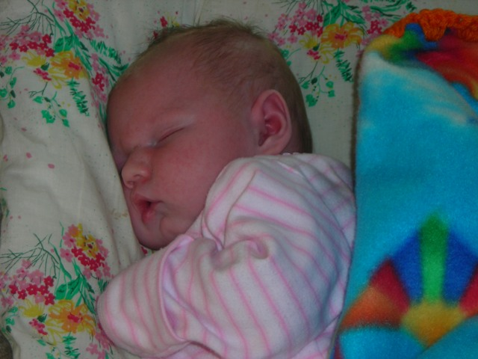
Obviously the first thing I have to write about is the birth of our daughter ‘Jadyn Liana Mihai’. Jadyn was one of the 5% of babies born exactly on the day she was due (7th November). She weighed a healthy 8lb 4oz and has continued to grow at such a rapid rate that she’s already outgrown a lot of her clothes. Our lives haven’t been the same since and to be honest we can’t imagine how life was without her. She didn’t have the dark, gypsy complexion as we expected but she’s a fair haired, blue eyed beauty. It will be interesting to see if she has my curly hair! Jadyn is a very visual miracle from God because the doctors not only said I would not be able to conceive, but because of some health problems, the doctors were not always very encouraging about my pregnancy. By-the-way, God also took care of the health problems I had!

We’d like to take this opportunity to thank everyone who prayed for my health and Jadyn’s health throughout the pregnancy. Thank you, thank you. At the beginning of 2006 we couldn’t imagine what a gift from heaven God had in store for us. Sorin still cannot quit smiling!

Unexpected encouragement.

A few weeks ago a 15 yr old girl came to Casa Vietii for a pregnancy test. The test was positive and she’d already made up her mind to have an abortion. She informed me that she’d had abortions before, that she was still at school, had no money etc etc etc. I’m ashamed to say that because I’d had a bad day, I reacted to her excuses and really laid into her. I showed her every video we had, gave her every brochure we had and spoke very direct. On one of my last visits to the doctor before my delivery I was sat in the waiting room when who should walk in but the same girl, along with her mother and boyfriend. She said that I’d really made her think about what she was doing and had decided to keep the baby, she’s now 5 months pregnant! When she left Casa Vietii that day I really felt that she was going to proceed to terminate the pregnancy and felt that I was wasting my time, I felt bad about how hard I was with her. We never know what God is doing and don’t realise that He can use our weaknesses and ‘bad days’ to change situations. Praise the Lord for His grace.

God’s Provision

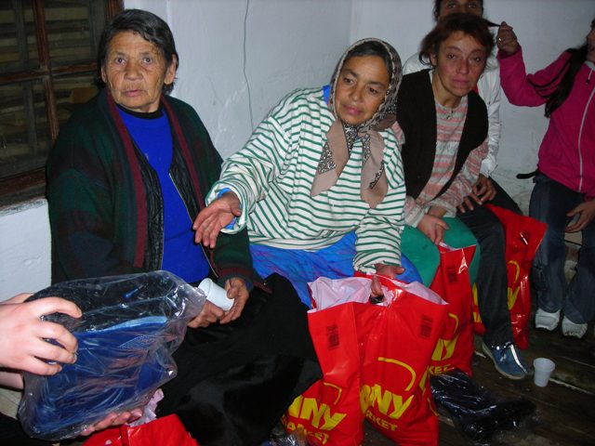
In mid-October, the practical work stopped at Casa Vietii while we were on maternity leave but Mia and Lidia have continued the work in the villages. Thanks to a generous gift from Americans Sarah and Chuck Mielke, we were able to give packages of food to each of the women in our programs in the villages. These packages were such a blessing to the families during the holidays and helped the ladies make Christmas special in their homes. Pictured here are some ladies from the group in Secuieni receiving food packages for Christmas. We also received some boots from one of the teams that come on a regular basis and gave them out for Christmas. Many in the villages do not have proper shoes and clothing for the cold winter months in Romania.

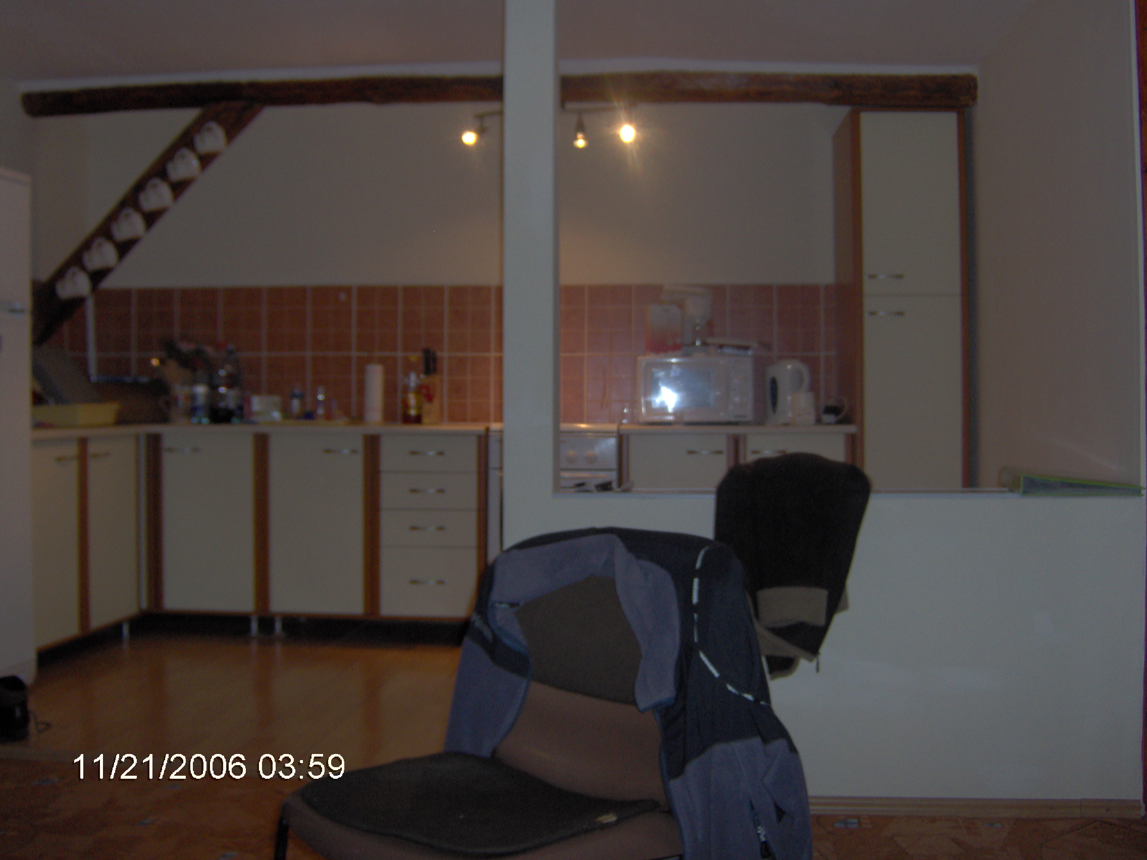
The work renovating Casa Vietii has continued. We were able to fit a new kitchen upstairs at and seems more like a home. It looks so much better than I imagined it would. Now the apartment is finished and is completely self contained. When we have guests, they will now be able to actually cook also!!

Again, thanks to the generosity of Sarah and Chuck, we were able to continue to support our two faithful workers Fane and Vasile. We had to lay them off during our maternity leave and they were both very concerned on how they would feed their families and keep warm during the winter. We prayed that God would help us provide their support for the three months they could not work. His faithfulness to provide has been amazing and He already had the funds on the way before the need! Fane and Vasile have cared for their families during the holidays and will return to start work again on the Casa Vietii Women’s Shelter/Medical Clinic very soon! Again, we are praying to open Fall 2008.

We would also like to thank Cole and Jamie Hadarean in Boston for sending the money to help us repair our vehicle Lizzy. You might remember last newsletter how it had fallen into dangerous disrepair. We will also be able to do a major repair to the electrical system at Casa Vietii. The electrician said our system was very dangerous and we would have to replace the electricity meter and fuse box or take a chance of a fire.

Once again, God knew our needs and touched your hearts. Thanks again to everyone that has been faithful to keep us on your prayer list and those that have been able to give throughout the year.

Upcoming Events and Prayer Requests

We are looking forward to several visits the next few months. Our friend and former Sighi Team Member Chris (Manchester) Low from Scotland will be visiting at the end of January. Then, another friend and former Sighi Team member, Eamon and her husband Gordon are coming from London with a team of 15 students from Mattersey Bible College to help in February. We are so thankful that God has given us such close relationships and that their desire to see God work in Sighisoara is still alive and well!! We have many others coming throughout the year and I will be reporting on them as they arrive.

Mia and daughter Betina have both adjusted to starting school this past Fall. Mia had her first lot of semester exams this month towards her Social Assistant degree. She has to travel by train to Cluj (about a 3 hour journey) several weekends a month to complete class work and testing, while the remainder is completed online. Thanks to two of our churches, her tuition and a computer were provided. It has been difficult for Mia to study, be a full time mom and to manage the ministry especially during my maternity leave.
Lidia’s husband has been working in Amsterdam so she too has a lot of responsibility with her children and helping in the ministry. Please keep Mia and Lidia as well as their families in your prayers. I could not keep the ministry going without their faithfulness and our unity in serving God.

As some of you may know, to be a YWAM staff missionary, we all have to do a DTS (Discipleship Training School) which lasts about 6 months. I completed mine in 2001, Mia and Lidia have both completed theirs. But unfortunately, before we were married, Sorin started a DTS but was only able to complete his lecture phase. He was unable to continue with the outreach phase because of ill health that required an emergency hospital stay. Sorin has been part of this team for over 3 yrs but has been unable to officially qualify as a YWAM staff member. We’ve spoken to the national YWAM leadership team and they agree with us that Sorin needs to complete his DTS as soon as possible. We have contacted the leaders at the Constanta YWAM base located in eastern Romania. They will be conducting a DTS there and they are willing to receive us into the program. We will be leaving at the beginning of March and probably doing our outreach somewhere in Turkey. We’ll be away for 2 months. Please pray that we are able to raise the 2000 euros (approx. $2600) to pay for this outreach training and that Sorin can get enough insulin to last whilst we’re away. YWAM wants the family to come together and I will be able to help insure Sorin does not let his insulin get so unregulated that he cannot continue.

We cherish your prayers above everything. God has an amazing year planned for all of us. I wish I had space to share all the amazing things God is doing here in Sighisoara. This is a great place to invest your prayers and as God leads your finances. This is a place that God is working and lives are being changed for eternity!

Thank you for making 2006 such a special year. On behalf of the team here at Casa Vietii I would like to wish you all the very best for the coming year.

Please stay in touch. Let us know how we can pray for you. We need your encouragement and we want to be a blessing to all of you. Contact us if you need any more information or if you have any suggestions. For donations to any of the projects or the operation of Casa Vietii, please contact me at jillascough@hotmail.com.

May God richly bless each of you for your prayers and support,
Love Jill, Sorin, and the Casa Vietii team

The YWAM Sighi Team is trying to set up a way to receive all donations through the YWAM account here in Sighisoara. In the past, it has been difficult and expensive to send funds, but they are working on establishing a better way. It may take a while but I will send you the details as soon as I receive them.

Until then, please continue to use the account details you have.

If you are in the United States, contact Barbara Glenn at tbglenn@bellsouth.net
or

Choose Life, Inc.
2006 Franklin Street, Suite 204
Huntsville, AL 35801
Mark For: Romania
256.534.1996
www.chooselifehuntsville.org
for tax deductible donations.

NOTE: If you do not have high speed internet and have problems receiving a larger file, please let me know and I will send a copy without all the pictures.

If you would like to be removed from Casa Vietii email list, please send a reply with “Remove” in the subject line.

“For with God nothing shall be impossible.” Luke 1:37

